Lahore Garrison University
DHA Phase 6 Lahore



Student Name | Faiqa Altaf
Student Roll No | Fa23/BSCS/155
Section | D
Subject | Web Technology
Instructor Name | Mr. Muhammad Yousaf

Lab Task 6
Code:
XML code for portfolio
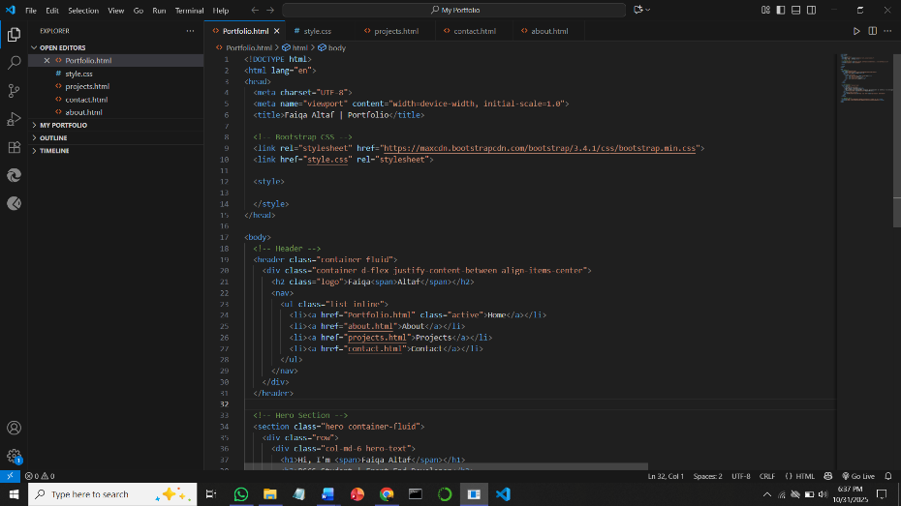
Output:

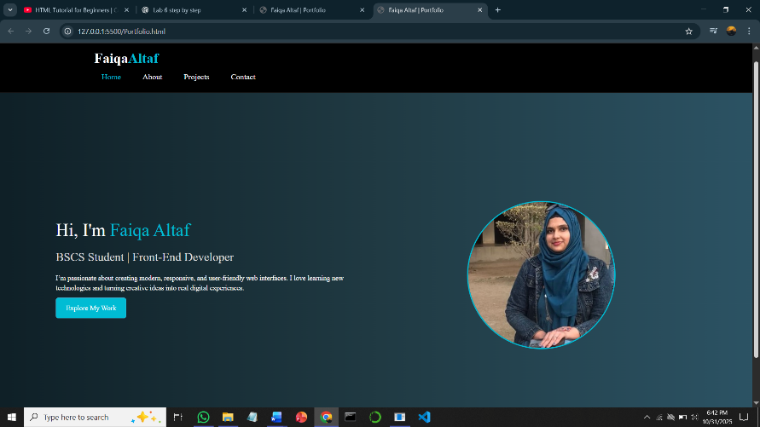
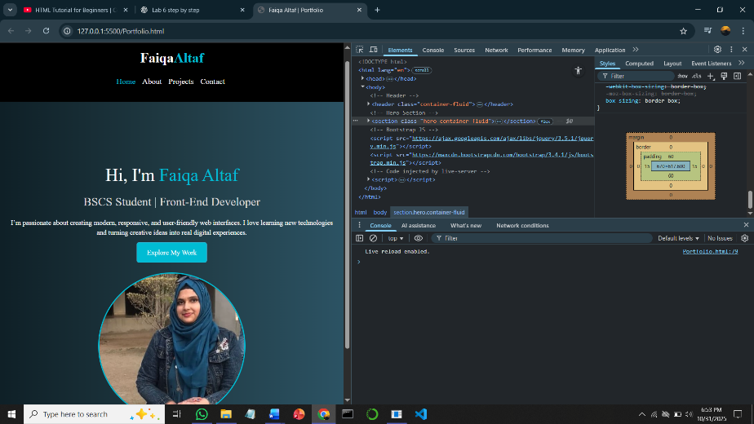

Validate:
